Dear friends of Sumo,

We would like to invite you to
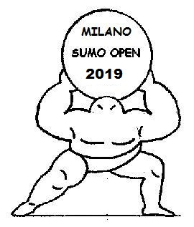

10 th Edition of

MILANO SUMO OPEN 2019

The competition will be

Saturday, 15 JUNE 2019,

in Sport Center Pini – Via Tommaso Pini 1

Milano, Italy

Categories:

Women - 65kg, - 80kg, + 80kg, Open, Team

Men -70 kg, - 85kg, -92 kg, - 115kg, + 115kg Open, Team


Sincerely
Fausto Emilio Gobbi
Organizer of Milano Sumo Open 2008


E-mail: sumoopen@hotmail.com
Mobilphone: +39 3405861541

WWW.SUMOOPEN.COM

PROGRAM OF MILANO SUMO OPEN 2019

Friday 14. June

Arrival of delegations, weight in and registration.

Saturday 15. June

11.00 Start of competition
Women category 65 kg, 80 kg, +85 kg, open, team

12.30 Opening ceremony

12.45
Men category -70kg, -85 kg, -92 kg, -115 kg,+115 kg, open, team

WWW.SUMOOPEN.COM
INFORMATION
HOTEL: First 5 team that will make registration before 15. March will have 2 double room free for athlete for 2 nights in official hotel.

AIRPORT: Milano have 3 international airports
-Malpensa 60 km to central station
- Linate 7 km to central station
- Orio al Serio 30 km to central station

Please let us know if you need transport from /to airport from/to hotel: you will get special price

COMPETITION
FEE: 30 EURO per athlete (include category, open and team), other official 15 EUR (include food and drink competition day, memory medal).

REGISTRATION:

Deadline for registration is 1 May.

PARTY: Sumoparty cost 35 EUR (for athletes and other officials)

Welcome to Milano Sumo Open 2019!
We are waiting for your registration!

Please let us know if you have any questions:
sumoopen@hotmail.com WWW.SUMOOPEN.COM

